**GANPAT UNIVERSITY**

**U. V. PATEL COLLEGE OF ENGINEERING**

**B.Tech CE/IT Semester IV**

**2CEIT404: Python Programming**

**Practical-6: Function(UDF)**

1. Write a program to perform addition of two numbers using user defined function.

**Code:**

def add_num(num1,num2):

    sum=num1+num2

*return* sum

num1=int(input("Enter First Number:"))

num2=int(input("Enter second number:"))

print("Sum:",add_num(num1,num2))

**Output:**

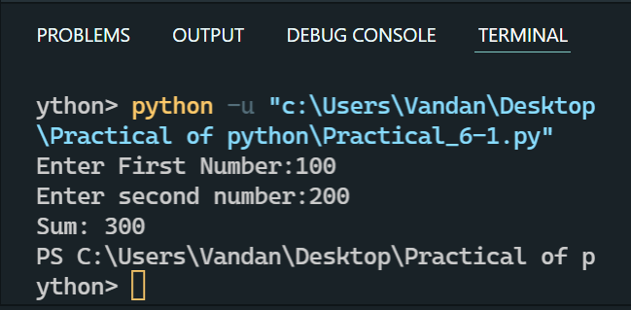

1. Write a program to display all the prime numbers between 1 to n using function.

Code:

n = int(input("Enter the number:"))

*for* i *in* range (1,n+1):

    temp =0

*for* j *in* range(2,i-1):

*if*(i%j==0):

            temp = 1

*break*

*if*(temp==0):

        print(i,end= " ")

Output:

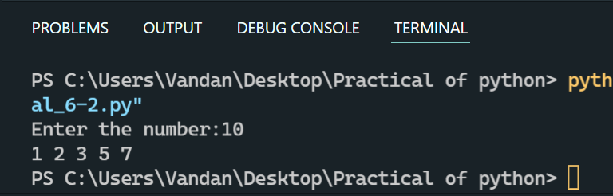

1. Write a user defined function to sort a List.

Code:

l1=[5,3,1,6,2,4]

def sorting(l1):

*for* i *in* range(0,len(l1)):

*for* j *in* range(i+1,len(l1)):

*if*(l1[i]>l1[j]):

                temp=l1[i]

                l1[i]=l1[j]

                l1[j]=temp

*return* l1

ans=sorting(l1)

print(ans)

Output:

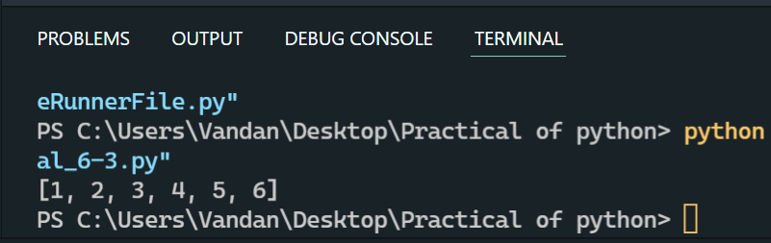

1. Write a function to find the minimum and maximum value from argument list & return both minimum & maximum in tuple form.

Code:

test_list = [(2, 3), (4, 7), (8, 11), (3, 6)]

print ("The original list is : " + str(test_list))

res1 = min(test_list)[0], max(test_list)[0]

res2 = min(test_list)[1], max(test_list)[1]

print ("The min and max of index 1 : " + str(res1))

print ("The min and max of index 2 : " + str(res2))

Output:

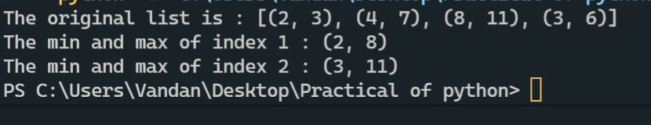

1. Write a function to add two lists of the same length term-by-term & return new list

Eg.: A=listAdd([1,2,3],[1,2,3]

print (A) Will print [2,4,6].

Code:

l1 = [12,54,89,15,54,78,45,31,15,94,31,13]

l2 = [21,65,34,98,76,34,94,31,13,74,35,64]

l3 =[]

def listAdd(l1,l2,l3):

*for* i *in* range(len(l1)):

        l=l1[i]+l2[i]

        l3.append(i)

listAdd(l1,l2,l3)

print("List 1:",l1)

print("List 2:",l2)

print("List 1+2 :",l3)

Output:

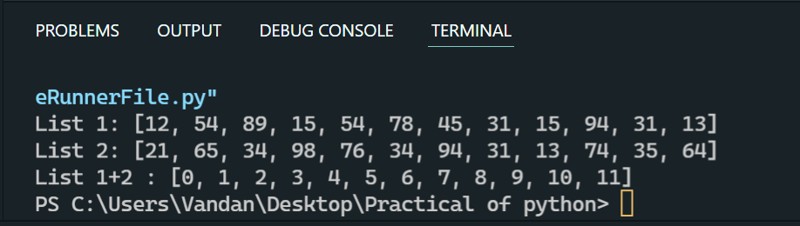

1. WAP a function called powers(n) that prints out the first 5 powers of a given number.

Eg. >>> powers(6)

The first 5 powers of 6 are: 1 6 36 216 1296

Code:

l1 =[]

a =int(input("ENter the number : "))

def powers(n):

*for* i *in* range(5):

        a=n**i

l1.append(a)

    print(l1)

powers(a)

Output:

